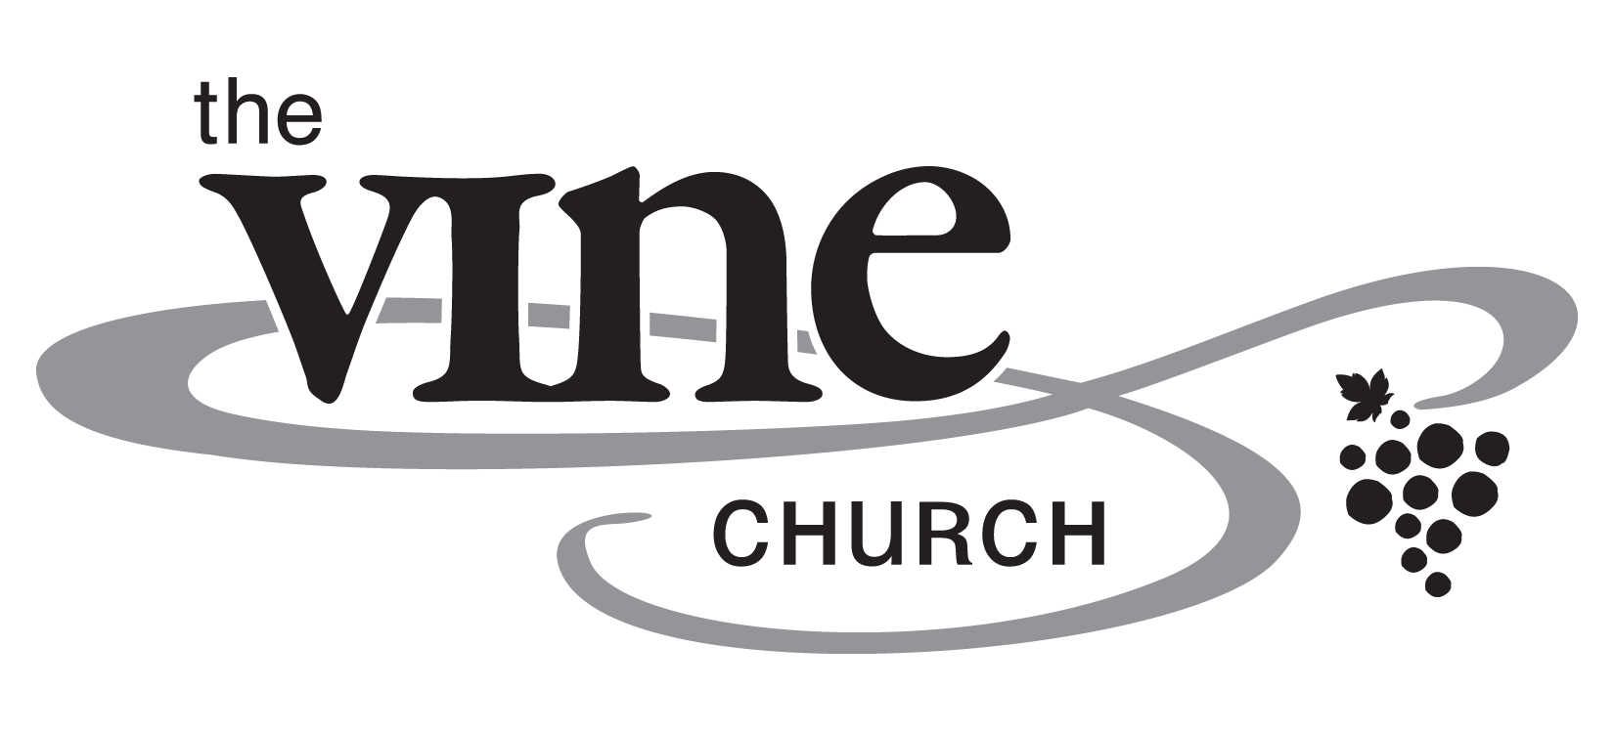,

*Test the Spirit*

The Power of Love – Part 6

I John 4

February 24, 2019

Pastor Todd Schlechty

Q. How do you know when you have found true love?

*“We must discover the power of love, the power, the redemptive power of love. And when we discover that we will be able to make of this old world a new world. We will be able to make men better. Love is the only way.”*

- Martin Luther King, Jr.

1. The Key to the Power of Love. (I John 3:23-24)

I John 3:23-24 *This is His commandment, that we believe in the name of His Son Jesus Christ, and love one another, just as He commanded us. 24 The one who keeps His commandments abides in Him, and He in him. We know by this that He abides in us, by the Spirit whom He has given us.*

How do we receive the power of God’s love in our lives?

1. __________________________________
2. __________________________________
3. The Warning: _______________________.

I John 4:1-6 *Beloved, do not believe every spirit, but test the spirits to see whether they are from God, because many false prophets have gone out into the world. 2 By this you know the Spirit of God: every spirit that confesses that Jesus Christ has come in the flesh is from God; 3 and every spirit that does not confess Jesus is not from God; this is the spirit of the antichrist, of which you have heard that it is coming, and now it is already in the world. 4 You are from God, little children, and have overcome them; because greater is He who is in you than he who is in the world. 5 They are from the world; therefore they speak as from the world, and the world listens to them. 6 We are from God; he who knows God listens to us; he who is not from God does not listen to us. By this we know the spirit of truth and the spirit of error.*

* *Beloved* –

How do we test the spirit?

1. Does it Confess _____________________________? (Vs. 2-3)
2. Does it represent _____________________________? (Vs. 4-6)

Point:.

Doggy Bag: Something to take home and chew on!



1. What do you believe is the secret to your best life? What is the answer to your deepest questions? What is the way to the place you should go in life? What is the truth that you can believe in?
2. How have you tested those who claim to be the secret to your best life, the answer to your questions, the way to eternity, the truth you can believe in?
3. What would your life look like if you tested every spirit with these two tests? (1) Does it confess Jesus Christ as God who has come down from heaven, in the flesh, for the world? (2) Does it represent the values of the Kingdom of God or the values of the world?