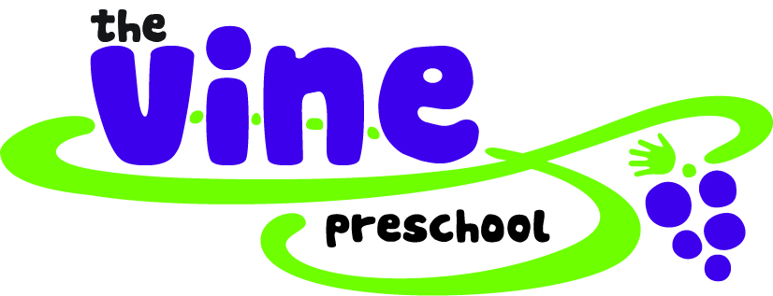
2501 Gallows Road
Dunn Loring, VA 22027
703.953.4599
preschool@thevineva.org

PARENT HANDBOOK AGREEMENT
School Year 2019-2020

For parents with students enrolled at Vine Preschool, please read the Vine Preschool Parent Handbook, and complete the form below acknowledging that you understand the policies of Vine Preschool. It is important that the handbook is read as it provides parents with information regarding the safety, development, and education of your child while attending Vine Preschool. Vine Preschool must receive this signed form before your child starts school.

Student’s Full Name ________________________________________________________________________________
(first name) (middle name) (last name)

Class Enrolled 2 ½ Year Old Class 3 Year Old Class 4 Year Old Class

By signing this form below, I affirm that I have read the Parent Handbook, and understand the policies of Vine Preschool. I agree to all policies, terms, and conditions as described in the Parent Handbook and I certify that the information provided on this form is accurate.

Parent / Guardian Parent / Guardian

Full name _________________________________ Full name __________________________________

Signature ____________________________________ Signature _____________________________________

Date ________________________________________ Date _________________________________________

