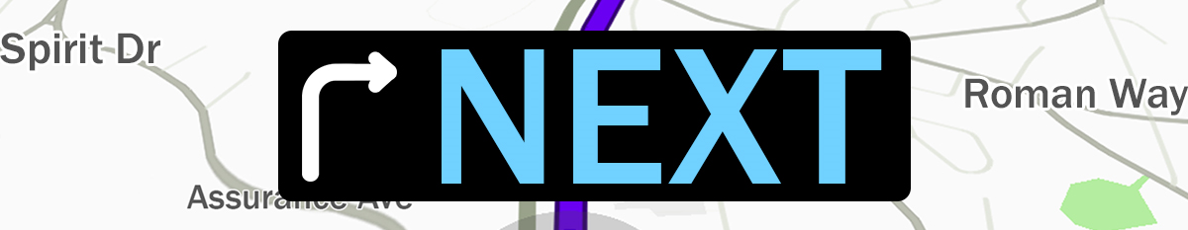
Pastor Todd Schlechty God For Us
July 29, 2018 Romans 8:31-39

Have you ever questioned God’s will for your life?
Have you ever questioned God’s love for you?
Have you ever questioned God’s grace?

The Basis of Your Next:
I. God is for __________________________________________.
Romans 8:31-32 What then shall we say to these things? If God is for us, who is against us? ³²He who did not spare His own Son, but delivered Him over for us all, how will He not also with Him freely give us all things?

II. God says, “You Are __________________________________”.
Romans 8:33-34 Who will bring a charge against God's elect? God is the one who justifies; ³⁴who is the one who condemns? Christ Jesus is He who died, yes, rather who was raised, who is at the right hand of God, who also intercedes for us.

III. Nothing can keep you from____________________________.
Romans 8:35-39 Who will separate us from the love of Christ? Will tribulation, or distress, or persecution, or famine, or nakedness, or peril, or sword? ³⁶Just as it is written, "FOR YOUR SAKE WE ARE BEING PUT TO DEATH ALL DAY LONG; WE WERE CONSIDERED AS SHEEP TO BE SLAUGHTERED." ³⁷But in all these things we overwhelmingly conquer through Him who loved us. ³⁸For I am convinced that neither death, nor life, nor angels, nor principalities, nor things present, nor things to come, nor powers, ³⁹nor height, nor depth, nor any other created thing, will be able to separate us from the love of God, which is in Christ Jesus our Lord.

Point:



Doggy Bag: Something to take home and chew on!
- What does it mean to you to know that God is for you? How does it change the way you see yourself and your calling in life?
- When have you had someone make a charge against you? Against your integrity? Against your ability? Against your morality? How did you handle it? Was there any truth in the charge? Did it cause you to question yourself? Your ability? Your worth? How does it make you feel to know that God calls you worthy?
- What do you think keeps you from God’s love? What do you think keeps you from God’s next for your life? What would change in your life if you believed that nothing could keep you from God’s love and God’s next in your life?

If you’d like to talk personally and confidentially w/Pastor Todd about your relationship with Christ, please email pastortodd@thevineva.org or call 703-573-5836 to set up an appointment.

