
Pastor Kris Beckert Deep Faith June 3, 2018 2 Kings 3:9-24

If the water in the swimming pool represents your faith in God, which person best represents where you’re at? Circle him/her.
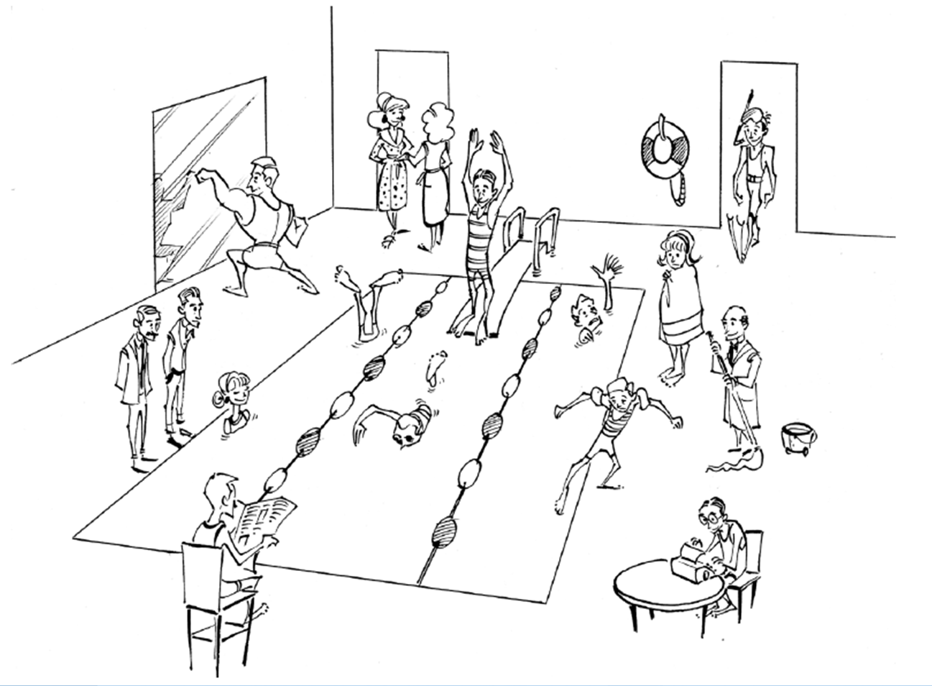

How do you cultivate a deep faith?

I. Recognize your ______________________________________
2 Kings 3:9-11 So the king of Israel, the king of Judah, and the king of Edom set out. After they had traveled their indirect route for seven days, they had no water for the army or their animals. ¹⁰Then the king of Israel said, “Oh no, the Lord has summoned three kings, only to hand them over to Moab.” ¹¹But Jehoshaphat said, “Isn’t there a prophet of the Lord here? Let’s inquire of Yahweh through him.”

II. Live it out __________________________________________
2 Kings 3:11-15 One of the servants of the king of Israel answered, “Elisha son of Shaphat, who used to pour water on Elijah’s hands, is here.” ¹²Jehoshaphat affirmed, “The Lord’s words are with him.” So the king of Israel and Jehoshaphat and the king of Edom went to him. ¹³Elisha said to King Joram of Israel, “We have nothing in common. Go to the prophets of your father and your mother!” But the king of Israel replied, “No, because it is the Lord who has summoned these three kings to hand them over to Moab.” ¹⁴Elisha responded, “As the Lord of Hosts lives, I stand before Him. If I did not have respect for King Jehoshaphat of Judah, I would not look at you; I wouldn’t take notice of you. ¹⁵Now, bring me a musician.”

III. Dig ________________________________________________
2 Kings 3:15-18 While the musician played, the Lord’s hand came on Elisha. ¹⁶Then he said, “This is what the Lord says: ‘Dig ditch after ditch in this wadi.’ ¹⁷For the Lord says, ‘You will not see wind or rain, but the wadi will be filled with water, and you will drink—you and your cattle and your animals.’ ¹⁸This is easy in the Lord’s sight. He will also hand Moab over to you…”

2 Kings 3:20, 24 About the time for the grain offering the next morning, water suddenly came from the direction of Edom and filled the land… ²⁴However, when the Moabites came to Israel’s camp, the Israelites attacked them, and they fled from them. So Israel went into the land and struck down the Moabites.

Point:


Doggy Bag: Something to take home and chew on!

- Has there been a time in your life when your faith collapsed? What happened?
- What do you think you need the most right now? When have you recognized your need for God the most?
- Do you tend to go to God only when you need something? How has God met or not met your expectations?
- When has your faith been the deepest—alone or shared in community? Who in your life has helped deepen your relationship with God?
- What “ditch” do you need to dig?

If you’d like to talk personally and confidentially w/Pastor Kris about your relationship with Christ, please email krisbeckert@thevineva.org or call 215-237-4959 to set up an appointment.

