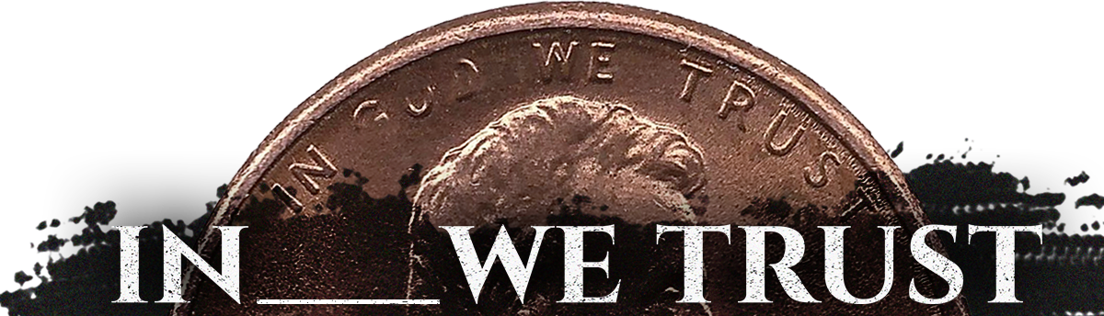
Pastor Todd Schlechty Trusting People
June 3, 2018 1 Samuel 18:1-9ff

Q. Have you ever had a friendship that was so close you felt like your two souls were one?

Q. How do you create that kind of relationship?

Creating Life’s Best Relationships:

I. The Key to Life’s Best Relationship--______________________
I Sam. 18:1-5 Now it came about when he had finished speaking to Saul, that the soul of Jonathan was knit to the soul of David, and Jonathan loved him as himself. ²Saul took him that day and did not let him return to his father's house. ³Then Jonathan made a covenant with David because he loved him as himself. ⁴Jonathan stripped himself of the robe that was on him and gave it to David, with his armor, including his sword and his bow and his belt. ⁵So David went out wherever Saul sent him, and prospered; and Saul set him over the men of war. And it was pleasing in the sight of all the people and also in the sight of Saul's servants.

- The soul of Jonathan was knit to the soul of David (V. 1)
- Jonathan loved him as himself. (V. 1)
- Jonathan made a covenant with David (V. 3)
- He loved him as himself. (V. 3)
- Jonathan stripped himself of the robe that was on him and gave it to David…armor…sword…bow…and belt. (V. 3)

How?
1. Become a __________________________________________.

2. Trust another ____________________.

II. The Enemy of Life’s Greatest Relationship--_______________
I Sam. 18:6-10 It happened as they were coming, when David returned from killing the Philistine, that the women came out of all the cities of Israel, singing and dancing, to meet King Saul, with tambourines, with joy and with musical instruments. ⁷The women sang as they played, and said, "Saul has slain his thousands, and David his ten thousands." ⁸Then Saul became very angry, for this saying displeased him; and he said, "They have ascribed to David ten thousands, but to me they have ascribed thousands. Now what more can he have but the kingdom?" ⁹Saul looked at David with suspicion from that day on. ¹⁰Now it came about on the next day that an evil spirit from God came mightily upon Saul, and he raved in the midst of the house, while David was playing the harp with his hand, as usual; and a spear was in Saul's hand.

- Envy = __________________________________________

“Envy is crazy… It is 100 percent destructive. If you get those things out of your life early, life works a lot better.”-- Charlie Monger

- Do you have a relationship like Jonathan and David?

- Do you have any relationships like King Saul and David?

Point: ________________________________________________

How? ________________________________________________


Doggy Bag: Something to take home and chew on!
- Have you ever had a relationship that was so close you felt like your souls were one? Based on trust, covenantal faithfulness, and sharing? What was that like?
- Have you ever had a relationship that was destructive? Based on envy, mistrust, and competition?
- When (in what relationship) have you acted in a trustworthy manner? When (in what relationship) have you acted in a trusting manner? When (in what relationships) have you acted in envious ways? What have been the results for each?
- What could you learn from your relationship with Jesus, to transform the way you live in relationship with others?

If you’d like to talk personally and confidentially w/Pastor Todd about your relationship with Christ, please email pastortodd@thevineva.org or call 703-573-5836 to set up an appointment.

