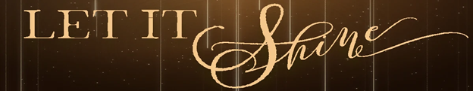

Pastor Todd Schlechty Joseph Shines
December 23, 2018 Matthew 1:18-25

John 1:4-5 In him was life, and the life was the light of all people. ⁵The light shines in the darkness, and the darkness did not overcome it. (NRS)

Matthew 5:14-16 "You are the light of the world. A city built on a hill cannot be hid. ¹⁵No one after lighting a lamp puts it under the bushel basket, but on the lampstand, and it gives light to all in the house. ¹⁶In the same way, let your light shine before others, so that they may see your good works and give glory to your Father in heaven. (NRS)

How to Experience the Light in Dark Times:

I. ___________________________________ for the Light.
Matthew 1:18-19 Now the birth of Jesus Christ was as follows: when His mother Mary had been betrothed to Joseph, before they came together she was found to be with child by the Holy Spirit. ¹⁹And Joseph her husband, being a righteous man and not wanting to disgrace her, planned to send her away secretly.

II. ___________________________________ for the Light.
Matthew 1:20-23 But when he had considered this, behold, an angel of the Lord appeared to him in a dream, saying, "Joseph, son of David, do not be afraid to take Mary as your wife; for the Child who has been conceived in her is of the Holy Spirit. ²¹She will bear a Son; and you shall call His name Jesus, for He will save His people from their sins." ²²Now all this took place to fulfill what was spoken by the Lord through the prophet: ²³"BEHOLD, THE VIRGIN SHALL BE WITH CHILD AND SHALL BEAR A SON, AND THEY SHALL CALL HIS NAME IMMANUEL," which translated means, "GOD WITH US."

III. _____________________________________ the Light.
Matthew 1:24-25 And Joseph awoke from his sleep and did as the angel of the Lord commanded him, and took Mary as his wife, ²⁵but kept her a virgin until she gave birth to a Son; and he called His name Jesus.

Point:

Doggy Bag: Something to take home and chew on!

- Where have you faced difficult circumstances? What does it look like for you to shine in those dark places?
- When have you heard God speak to you? How? How did you respond?
- How will you shine this Christmas?
- How are you looking for the Light in your circumstances this Christmas?
- How are you listening for the Light?

If you’d like to talk personally and confidentially w/Pastor Todd about your relationship with Christ, please email pastortodd@thevineva.org to set up an appointment.

