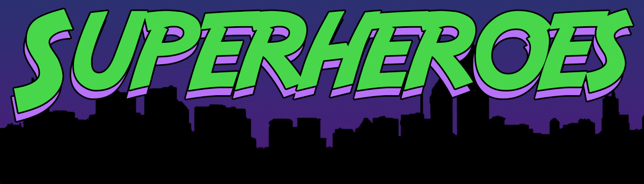

Pastor Todd Schlechty Ordinary Superhero
November 25, 2018 Hebrews 11:32-40

Q. Who is your hero?______________________________

Review Series:

- God is the _______________________________________________.
- We receive God’s superpower by _____________________________.
- God’s superheroes are the most ______________________________.

Hebrews 11:32-40 And what more shall I say? For time will fail me if I tell of Gideon, Barak, Samson, Jephthah, of David and Samuel and the prophets, ³³who by faith conquered kingdoms, performed acts of righteousness, obtained promises, shut the mouths of lions, ³⁴quenched the power of fire, escaped the edge of the sword, from weakness were made strong, became mighty in war, put foreign armies to flight. ³⁵Women received back their dead by resurrection; and others were tortured, not accepting their release, so that they might obtain a better resurrection; ³⁶and others experienced mockings and scourgings, yes, also chains and imprisonment. ³⁷They were stoned, they were sawn in two, they were tempted, they were put to death with the sword; they went about in sheepskins, in goatskins, being destitute, afflicted, ill-treated ³⁸(men of whom the world was not worthy), wandering in deserts and mountains and caves and holes in the ground. ³⁹And all these, having gained approval through their faith, did not receive what was promised, ⁴⁰because God had provided something better for us, so that apart from us they would not be made perfect.

- Gideon (Judges 6-8)
- Barak (Judges 4)
- Samson (Judges 11-12)
- Jephthah (Judges 13-16)
- David (I & II Samuel)
- Samuel (I Samuel)
- Prophets

Hebrews 11:39-40 And all these, having gained approval through their faith, did not receive what was promised, ⁴⁰because God had provided something better for us, so that apart from us they would not be made perfect.

3 Truths about God’s Heroes:
- Heroes won by ___________________________________________.
- They did not receive what was _______________________________.
- They could not receive God’s promise _________________________.

Point:

Doggy Bag: Something to take home and chew on!

- “Who is your hero?” Who has inspired you? Who is the person you seek to emulate?
- Who is the person who has saved your life?
- How might God be calling you to be His hero in someone else’s life?
- Who might God be calling you to be a hero to?
- What would you do to be someone else’s hero this week?

If you’d like to talk personally and confidentially w/Pastor Todd about your relationship with Christ, please email pastortoddt@thevineva.org to set up an appointment.

